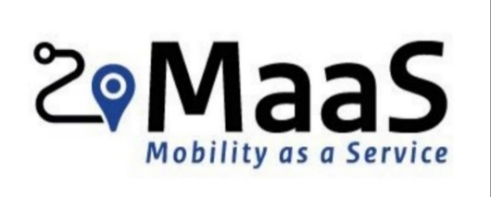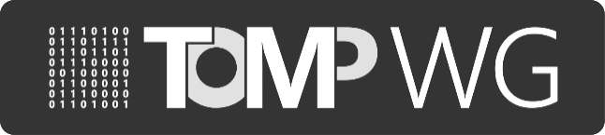

**Report of MaaS-API working group**

*3/2/2021, session #41  
10:00h-11:00h, Teleconference*

*Attended by (11)*

Bon Bakermans (Ministry of IenW)

Christiaan Rakowski ( XXIMO)

Eddy Borremans (Nazza)

Edwin van den Belt (DAT Mobility)

Kushagra Sharma (Radiuz)

Marijn Roverts (PON)

Ross Curzon-Butler (Cargoroo)

Ruud Mollema (Ministry of IenW)

Stefan Bollars (Innovactory)

Tjalle Groen (Taxistop)

Tu-Tho Thai (MobilityData)

**Summary of decision points & feedback from actions from previous working session**

The following tasks were defined during the previous sessions:

|  |  |  |  |  |
| --- | --- | --- | --- | --- |
| *No.* | *Context* | *Task* | *Status* | *Due date* |
| 41.1 | List of implementors | Will be updated by WT2  Will be published on the website by WT4 | To do | 17-2-2021 |
| 41.2 | Proposal for members of SC | **Bon** to make a short list. Any input is welcome | To do | 17-2-2021 |
| 41.3 | Blueprint of CDS-M | **Ross** to share the blueprint of CDS-M and to present it during the next working group | To do | 17-2-2021 |

1. **Approval of report of previous working session**The report of the previous working session (#40) was reviewed during this session and has been approved. It will be added to GitHub.
2. **Organisational structure by Bon**
   * Joined structure for TOMP-API, CDS-M, learning environment API, and others
   * More formal governance is needed to arrange upcoming developments like: the publishing of standards, paid or elected tasks, certification, international scale up and versioning
   * Strategic Committee:
     + is responsible for strategic decisions
     + consists of public and private members that are appointed for one year
   * Change Advisory Board:
     + gives advice to the SC and is open for every stakeholder
     + specific and temporary working groups for technical development
   * The working group comes to the conclusion that it is too soon to ask members for fees to join TOMP-WG. Currently, Mobility Data Foundation makes use of payed memberships.
   * The future structure should not be owned by the ministry or any other government. The members of the SC should therefore be carefully picked. To be discussed in the next meeting.
   * The openness of TOMP-WG is a great driver and should be maintained in the future structure. Furthermore, we have to make sure the initiative stays international.
3. **WT1 Technical issues** 
   * Number of issues is still limited that the frequency of meetings is reduced.
4. **WT2 Reference implementation and certification**
   * Contacted UMOS. TOMP-WG is going to play a major role in their view on a MaaS ecosystem. Conversational with UMOS will be continued.
   * Working on a list of known implementations of TOMP-API. Ready to be published in two weeks (41.1).
5. **WT3 Standards**
   * Working on a mapping of TOMP-API and OSLO. The university of Antwerp has done some mappings. Those will be updated in the coming months. This could also be helpful for the MaaS alliance.
6. **WT4 Dissemination and communication**

* Website is also available in secure environment: HTTPS
* Upcoming participations: Dutch [MaaS congres](https://www.maascongres.nl/) and [ITS world congress](https://itsworldcongress.com/)

1. **Any Other Business and next meeting**

* The Open Mobility Foundation made a proposal for a metrics API for upgrade MDS. This makes it redundant to make a separate standard in the Netherlands/Europe. CDS-M working group is now looking into ways to make an interpretation of MDS. Ross will give an update on the development of CDS-M.
* Sonila will give an update on the progress of the Afsprakenstelsel in the next meeting.

**Next online meeting (working session #42) will be on Wednesday 17-2-2021, 10:00h**